Does Higher Medicare Spending Lead to Longer Lives? Analyzing the Relationship Between Per-Capita Medicare Expenditure and Life Expectancy Across U.S. States
Project proposal
Principal Investigators: Srijan Gupta sgupta285@wisc.edu, Robin Li rli439@wisc.edu, Emily Jimenez ejimenez@wisc.edu, Krithika Shetty kshetty@wisc.edu

Questions to be addressed
In this study, we want to understand whether spending more on Medicare actually leads to people living longer lives. Specifically, we’re looking at the relationship between how much each U.S. state spends on Medicare per person and the average life expectancy in that state. Do states that spend more see better health outcomes, or does spending more not always make a difference?
This is an important question because Medicare makes up a large part of federal healthcare spending, and knowing whether that money is being spent effectively matters. If more spending is strongly tied to longer life expectancy, it could support the case for increased investment in Medicare. On the other hand, if there’s little connection, it might suggest that there are other factors—like income levels, education, or access to care—that play a bigger role, and simply spending more isn’t enough.
To dive deeper into this, we’ll focus on these five key questions:
- Is there a statistically significant relationship between how much a state spends on Medicare per person and how long people live in that state?
- Do states that spend more on Medicare always see higher life expectancy, or are there exceptions?
- Is there a point where spending more on Medicare stops making much difference in life expectancy (i.e., diminishing returns)?
- How do factors like income, education, and poverty influence the link between Medicare spending and life expectancy?
- Are there clear regional trends—like differences between the South, Northeast, Midwest, and West—in how Medicare spending relates to life expectancy?
Data
[Document the data you are using. Where is it from? What is the unit of observation? What is the coverage? Which variables are most important?
Discuss any shortcomings of the data.]
Medical Expenditure Panel Survey Public Use File Details
Health Insurance Coverage and Type by State
Healthcare Insurance Expenses
Health Care Costs by State 2025
Life Expectancy by State 2025
Happiest States 2025
The data we are using are from multiple sources from U.S. census data. We are observing medical expenditures, coverage types, life expectancy, and qualitative measures of life. The units include expenditures per capita, average life expectancies, average happiness scores, etc. This spread of data helps observe the impacts of medical expenses on multiple factors. This data is additionally helpful because it includes information on multiple years so we can observe the changes in healthcare spending.

Proof of concept
[Include one table or figure that provides preliminary evidence that you can answer your question with your data. Provide a brief explanation of the figure.]
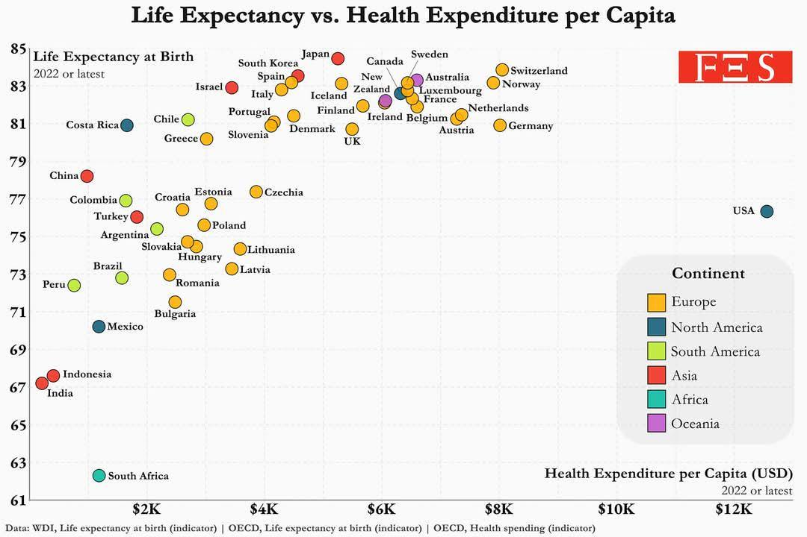

This figure shows the relationship between health expenditure per capita and life expectancy at birth across different countries. Each point represents a country, colored according to its continent. The trend shows a positive correlation. Countries that spend more on healthcare per capita tend to have higher life expectancies. The U.S. is an outlier, with much higher health expenditure but lower life expectancy compared to other wealthy nations.

